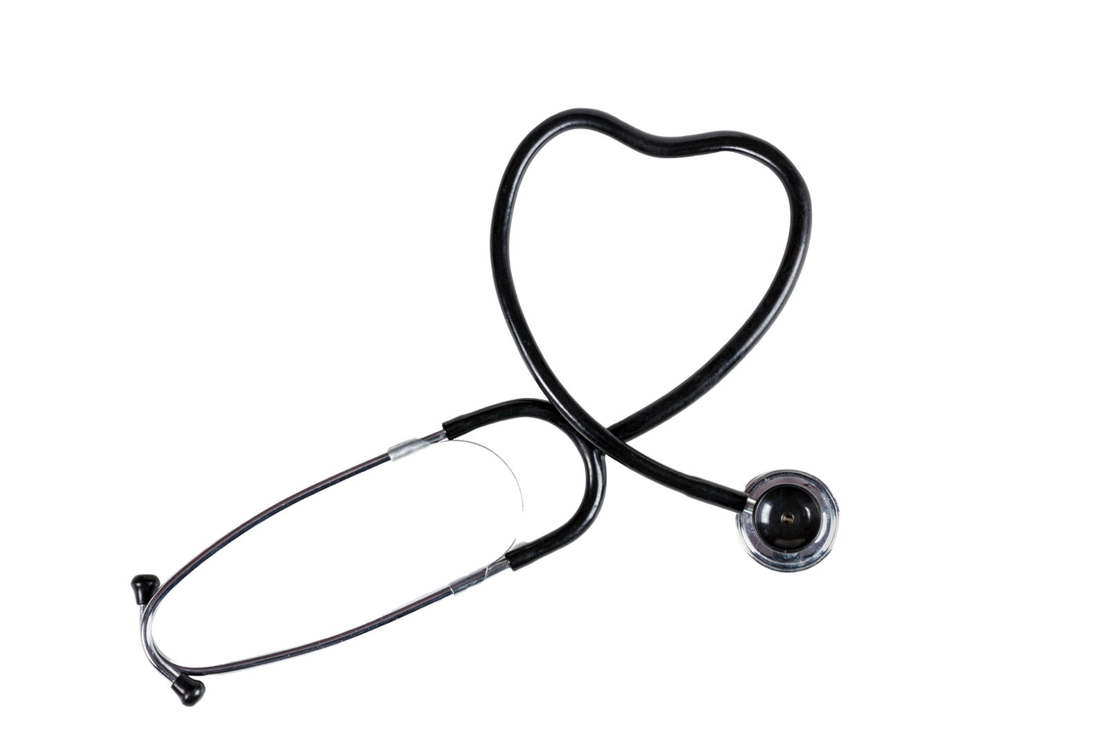
Physical exams paired with a forensic interview improve case outcomes
Sexual assault and abuse exams strengthen cases and benefit your child

As a parent you have the right to refuse a physical exam of your child.
Before making a decision, know these facts:
- The purpose of the exam is to assess the physical and mental well-being of your child.
- The exam is not like adult exams. There are no internal implements or instruments.
- There are no shots.
- The exam is 100% free.
- Your child is in control. No part of the exam is forced or uses restraints.
- Trained forensic examiners are credentialed experts and have experience working with children.
- We want to let your child know they are not damaged, it was not their fault, and they are completely normal.
- The entire process from start-to-finish is about 60-90 minutes.
- Even if your child has been seen by a doctor, we strongly recommend you bring your child to a forensic examiner.
- Unless the event occurred in the last 72 hours, the exam doesn’t have to be today.

Contact information for medical referrals

